Filtering
A filter can emphasize or de-emphasize certain parts of the frequency spectrum of a sound. Visually, it can be shown as a graph over the frequency domain called a frequency response, consisting of both magnitude response and phase response. For each frequency, the higher the value of the graph, the more emphasis is placed on that part of the frequency range. A graph sloping downward places more emphasis on low frequencies and less on high frequencies.
Here, we look at the Web Audio API's two nodes that perform filtering, the BiquadFilterNode, and the IIRFilterNode. The theory behind filtering is first introduced, with a focus on the different types of filters implemented with the biquad filter. Then example source code is given for use of the biquad filter node and visualizing its frequency response. A similar example is given for the IIRFilterNode. Stability is also discussed, and code examples are given where each of these filters go unstable.

Filter Definition
Let b_{m} be the feedforward coefficients and a_{n} be the feedback coefficients. Then a linear, time-invariant filter is given by the time-domain equation,
$$\sum_{n=0}^{N}{a_{n}y[n-k]}=\sum_{m=0}^{M}{b_{m}x[n-k]}$$
By dividing all terms by a₀, one can get the current output as a function of previous outputs, and current and previous inputs. So, for instance, a one sample delay is just $y[n]=x[n-1]$, and averaging the current input and the last output is $y[n]=0.5y\left[n-1\right]+0.5x\left[n\right]$.
This can also be represented in the frequency domain. The transfer function of the general IIR filter is given by
$$H\left(z\right)=\frac{\sum_{m=0}^{M}{b_{m}z^{-m}}}{\sum_{n=0}^{N}{a_{n}z^{-n}}}$$
where M+1 is the length of the b array and N+1 is the length of the aa array. The coefficient a₀ must not be 0, and at least one of b_{m} must be non-zero.
Initially, all prior input and output values are set to zero. More details about these filters can be found in resources such as Audio Effects by Reiss MacPherson.
In the Web Audio API, we can apply such filters using the BiquadFilterNode or IIRFilterNode.

The BiquadFilterNode
Low-order filters are the building blocks of basic tone controls (bass, mid, treble), graphic equalizers, and more advanced filters. The BiquadFilterNode implements common filters as second order, or biquad filters. Multiple BiquadFilterNode filters can be combined to form more complex filters. The filter parameters such as frequency can be changed over time for filter sweeps, a wah-wah effect, a phaser etc.
Biquads continue to output non-silent audio with zero input. Since this is an Infinite Impulse Response (IIR) filter, the filter produces non-zero output forever to a single nonzero input sample. But in practice, this can be limited after some finite time where the output is sufficiently close to zero. The actual time depends on the filter coefficients.
Each BiquadFilterNode can be configured as one of a number of common filter types. The type parameter sets the type of filter. The default filter type is 'lowpass'.
These filters can be configured with three audio parameters: gain, frequency, and Q (the quality factor). These parameters all affect the frequency response graph differently. The meaning of the frequency, gain and Q parameters depends on the filter type, and is given in Table 11.A.
Table 11.A. Description of the BiquadFilterNode filter types, and their parameters.
Type | Description | Frequency | Gain | Q
lowpass | Resonant lowpass filter with 12dB/octave rolloff. Attenuates high frequencies. | Cutoff frequency | Not used | Resonance at the cutoff. More peaked with high Q.
highpass | Resonant highpass filter with 12dB/octave rolloff. Attenuates low frequencies. | Cutoff frequency below which frequencies are attenuated | Not used | Resonance at the cutoff. More peaked with high Q.
bandpass | Attenuates frequencies below and above a frequency band. | Center of the frequency band | Not used | Width of the band. Width narrows as Q increases.
lowshelf | Adds boost or cut to lower frequencies. | Upper limit of frequencies where boost or cut applied. | Boost in dB. Negative value gives attenuation. | Not used
highshelf | Adds boost or cut to higher frequencies. | Lower limit of frequencies where boost or cut applied. | Boost in dB. Negative value gives attenuation. | Not used
peaking | Adds boost or cut to range of frequencies. | Center frequency where boost or cut applied. | Boost in dB. Negative value gives attenuation. | Width of the band. Width narrows as Q increases.
notch | Attenuates frequency range. Also known as a bandstop filter. | Center frequency of where the notch is applied. | Not used | Width of the band. Width narrows as Q increases.
allpass | Changes phase relationship between the various frequencies. | Frequency where phase transition occurs, with maximal group delay. | Not used | Sharpness of phase transition. High Q gives sharp transition and large group delay.

The idealised form for each of these filters is given in Figure 11.1. In these plots, linear gain is on the y axis and frequency from DC (0 Hz) to Nyquist (sampling frequency / 2) is given on the x axis. f_{c} is the corner or cut-off frequency of the filter and B is the bandwidth, equivalent to f_{c} / Q where Q is the Quality Factor.
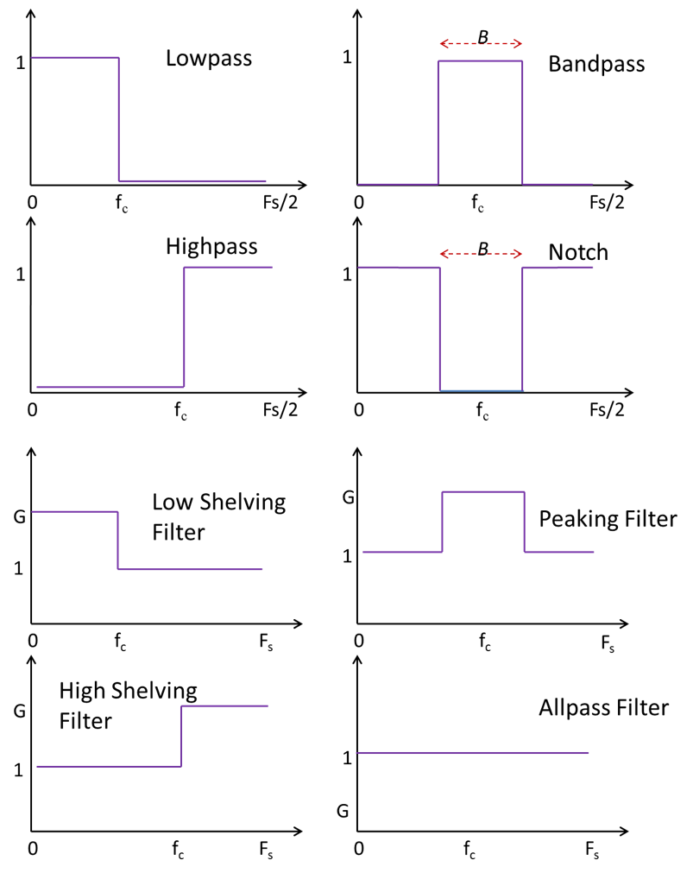
Figure 11.1. Magnitude response for various ideal filters.
These filters affect the sound in ways that relate to perception. Lowpass filtering often makes a sound more muffled, whereas highpass filtering can make it more tinny. A bandpass filter can keep just the midrange (often useful if focusing on speech in the presence of other, unwanted sounds). Graphic equalizers are often constructed using lowpass, highpass, and several bandpass filters in parallel, each one having an adjustable gain.
Low and high shelving filters can be used to adjust the bass and treble respectively, and peaking filters adjust the midrange. Shelving filters, in combination with at least one peaking filter, are used to construct parametric equalizers (Massenburg, 1972) used to shape the spectrum of a sound.
Notch filters, also known as bandstop or bandreject filters, are often used to remove a narrow frequency range, like when there is electrical hum.
Finally, the allpass filter leaves the magnitude response unchanged, but can change the phase response. Allpass filters are often used to construct other effects, such as the phaser.

Parameters
- type, default 'lowpass', see Table 11.A.
- frequency, default 350: The frequency at which the BiquadFilterNode will operate, in Hz. It forms a compound parameter with detune to form the computedFrequency. It ranges from 0 to the Nyquist frequency (half the sample rate).
- gain, default 0: The gain of the filter. Its value is in dB units. The gain is only used for lowshelf, highshelf, and peaking filters.
- Q, default 1: The Quality factor of the filter, representing the cutoff or corner frequency divided by the bandwidth. For lowpass and highpass filters the Q value is in dB. For these filters the nominal range is approximately –770.637 to +770.637. For the bandpass, notch, allpass, and peaking filters, Q is linear and can only assume positive values.
This is not used for the lowshelf and highshelf filters.
- detune, default 0: A detune value, in cents, that represents a shift in the corner or cutoff frequency. It forms a compound parameter with frequency to form the computedFrequency.
Both frequency and detune are a-rate. They are used together to form a compound parameter: computedFrequency(t) = 2^{detune(t)/1200}frequency(t)
The number of output channels always equals the number of input channels.

Filter characteristics
All of these biquad filters stem from a common mathematical model. The formulas for each filter type are inspired by formulas found in the Audio EQ Cookbook (Bristow-Johnson, 1994).
The BiquadFilterNode processes audio with a transfer function of
$$H\left(z\right)=\frac{b_{0}+b_{1}z^{-1}+b_{2}z^{-2}}{a_{0}+a_{1}z^{-1}+a_{2}z^{-2}}$$
which is equivalent to a time-domain equation of:
$$a_{0}y\left(n\right)+a_{1}y\left(n-1\right)+a_{2}y\left(n-2\right)=b_{0}x\left(n\right)+b_{1}x\left(n-1\right)+b_{2}x\left(n-2\right)$$
Where initial conditions, x[-1], x[-2], y[-1], y[-2], are all set to 0. We define F_{s} as the sample rate for this AudioContext, f₀ is the computed frequency, G the gain and Q the quality factor. Next we define some intermediate terms;
$$ω_{0}=2πf_{0}/F_{s},A={10}^{G/40}$$
$$α_{Q}=\frac{\sin{ω_{0}}}{2Q},α_{Q_{dB}}=\frac{\sin{ω_{0}}}{2⋅{10}^{Q/20}},α_{S}=\frac{\sin{ω_{0}}}{\sqrt{2}}$$
The six coefficients for each filter type, are:
'lowpass'
$$b_{0}=\frac{1-cos{ω_{0}}}{2},b_{1}=1-cos{ω_{0}},b_{2}=\frac{1-cos{ω_{0}}}{2}$$
$$a_{0}=1+α_{Q_{dB}},a_{1}=-2cos{ω_{0}},a_{2}=1-α_{Q_{dB}}$$

'highpass'
$$b_{0}=\frac{1+cos{ω_{0}}}{2},b_{1}=-1-cos{ω_{0}},b_{2}=\frac{1+cos{ω_{0}}}{2}$$
$$a_{0}=1+α_{Q_{dB}},a_{1}=-2cos{ω_{0}},a_{2}=1-α_{Q_{dB}}$$

'bandpass'
$$b_{0}=α_{Q},b_{1}=0,b_{2}=-α_{Q}$$
$$a_{0}=1+α_{Q},a_{1}=-2cos{ω_{0}},a_{2}=1-α_{Q}$$
'notch'
$$b_{0}=1,b_{1}=-2cos{ω_{0}},b_{2}=1$$
$$a_{0}=1+α_{Q},a_{1}=-2cos{ω_{0}},a_{2}=1-α_{Q}$$
'allpass'
$$b_{0}=1-α_{Q},b_{1}=-2cos{ω_{0}},b_{2}=1+α_{Q}$$
$$a_{0}=1+α_{Q},a_{1}=-2cos{ω_{0}},a_{2}=1-α_{Q}$$
'peaking'
$$b_{0}=1-α_{Q}A,b_{1}=-2cos{ω_{0}},b_{2}=1+α_{Q}A$$
$$a_{0}=1+α_{Q}/A,a_{1}=-2cos{ω_{0}},a_{2}=1-α_{Q}/A$$
'lowshelf'
$$b_{0} = A [ (A+1)-(A-1)cosω_{0}+2α_{S}\sqrt{A})]$$
$$b_{1}=2A[(A-1)-(A+1)cosω_{0}]$$
$$b_{2}= A[(A+1)-(A-1)cosω_0- 2α_{S}√A) ]$$
$$a_{0}=\left(A+1\right)+\left(A-1\right)\cos{ω_{0}}+2α_{S}\sqrt{A}$$
$$a_{1}=-2\left[\left(A-1\right)+\left(A+1\right)\cos{ω_{0}}\right]$$
$$a_{2}= (A+1) + (A-1) cos⁡ω_0 - 2 α_{S}\sqrt{A})$$
'highshelf'
$$b_{0} = A [ (A+1) + (A-1) cosω_{0}+ 2α_{S}\sqrt{A})]$$
$$b_{1}=-2 A [(A-1)+(A+1) cosω_0)]$$
$$b_{2}= A [ (A+1) + (A-1) cosω_{0}- 2α_{S}\sqrt{A}) ]$$
$$a_{0}=\left(A+1\right)-\left(A-1\right)\cos{ω_{0}}+2α_{S}\sqrt{A}$$
$$a_{1}=2\left[\left(A-1\right)-\left(A+1\right)\cos{ω_{0}}\right]$$
$$a_{2}= (A+1) - (A-1) cosω_{0}- 2 α_{S}\sqrt{A})$$

Methods
There is one method associated with the biquad filter, getFrequencyResponse(), which calculates the magnitude and phase response for specified frequencies. It has three parameters, frequencyHz, magResponse, and phaseResponse, which must be Float32Arrays of the same length.
- frequencyHz specifies an array of frequencies, in Hz, at which the response values will be calculated. The specified frequencies can go beyond Nyquist, but then the method returns NaN (Not a Number) at the corresponding magnitude and phase values.
- magResponse specifies an output array for the linear magnitude response values.
- phaseResponse specifies an output array for the phase response values in radians.

Example – biquad visualiser
The BiquadFilterNode can be used to build equalizers and manipulate sounds in interesting ways. It has support for all of the commonly used second-order filter types. We can configure these nodes with the same parameters as discussed in the previous section, and also visualize the frequency response graphs by using the getFrequencyResponse method on the node.
Code example 11.1 shows a small program to visualize all the Web Audio Api’s filter types and choice of filter parameters. A more advanced visualization would label the axes, present frequency on a log axis and magnitude in decibels, but this suffices to show the effect.
<button id='start'>Make noise</button>
<canvas id='canvas' width='600' height ='300' style='border:1px solid'></canvas><br>
<select id='Type' oninput='UICallback()'>
<option value='lowpass'>lowpass</option>
<option value='highpass'>highpass</option>
<option value='bandpass'>bandpass</option>
<option value='lowshelf'>lowshelf</option>
<option value='highshelf'>highshelf</option>
<option value='peaking'>peaking</option>
<option value='notch'>notch</option>
<option value='allpass'>allpass</option>
</select>
<br>Frequency<br>
<input id='Frequency' type='range' max=10000 value=800 oninput='UICallback()'>
<br>Q<br>
<input id='Q' type='range' min=-50 max=50 value=1 step='any' oninput='UICallback()'>
<br>Gain<br>
<input id='Gain' type='range' min=1 max=20 value=1 oninput='UICallback()'>
<script src='biquad.js'></script>

var audioContext = new AudioContext()
var canvasContext = canvas.getContext('2d')
var nFreqs = 100,
Freqs = new Float32Array(nFreqs),
Mags = new Float32Array(nFreqs),
Phases = new Float32Array(nFreqs)
for (var i=0;i<nFreqs;++i) Freqs[i] = 20000/nFreqs*(i+1)
var biquadFilter = new BiquadFilterNode(audioContext,{frequency:1000,Q:1,gain:1})
function UICallback() {
biquadFilter.frequency.value = Frequency.value
biquadFilter.Q.value = Q.value
biquadFilter.gain.value = Gain.value
biquadFilter.type = Type.value
biquadFilter.getFrequencyResponse(Freqs,Mags,Phases)
canvasContext.clearRect(0,0,canvas.width,canvas.height)
canvasContext.beginPath()
for (let i=0;i<nFreqs;++i)
canvasContext.lineTo(canvas.width*i/nFreqs,canvas.height-Mags[i]*90)
canvasContext.stroke()
}
start.onclick = () => {
audioContext.resume()
let source = new AudioBufferSourceNode(audioContext,{loop:true})
let nFrames = audioContext.sampleRate
source.buffer = audioContext.createBuffer(1,nFrames,audioContext.sampleRate)
for (i=0;i<nFrames;i++) source.buffer.getChannelData(0)[i] = 2*Math.random()-1
source.connect(biquadFilter).connect(audioContext.destination)
source.start()
}
Code example 11.1. Biquad.html and Biquad.js files to visualize the biquad filters.
The html file gives a canvas to draw the filter, range controls to adjust the filter parameters, and a select control to choose the type of filter. When the user clicks the ‘Make noise’ button, an AudioBufferSourceNode is created to generate one second of looped noise.
This buffer is connected to the filter, which in turn connects to the destination. A single callback function is attached to the controls for all filter parameters. Whenever a parameter is changed, the UICallback function is called. Here, all filter paramets are updated, the getFilterResponse method is called and the magnitude of the response is plotted on the canvas.

Comparison of filter designs
Default filter designs differ widely in different development environments, and the Web Audio API's filters are by no means standard. Here, we compare characteristics of these designs with those implemented in the visual programming environment PureData, which is similar to Max MSP and popular for audio applications, and the standard Butterworth filter designs found in the literature (Valimaki & Reiss, 2016),
Figure 11.2 shows typical magnitude responses for each of these lowpass filter designs. The standard Butterworth approach to low pass design uses a first order filter. So one specifies just the cut-off frequency, but not the quality factor Q. The PureData implementation is an approximation, less exact but quicker to calculate. It doesn’t go all the way to zero magnitude at Nyquist, since it does not use previous inputs (no z⁻¹ or z⁻² terms) in the numerator of the transfer function.
The Web Audio API filter uses a second order (biquad) resonant filter for its lowpass design. This resonant filter goes above unity gain around the corner frequency (that’s the resonance), and rolls off towards zero faster when beyond the corner frequency (due to it being high order).
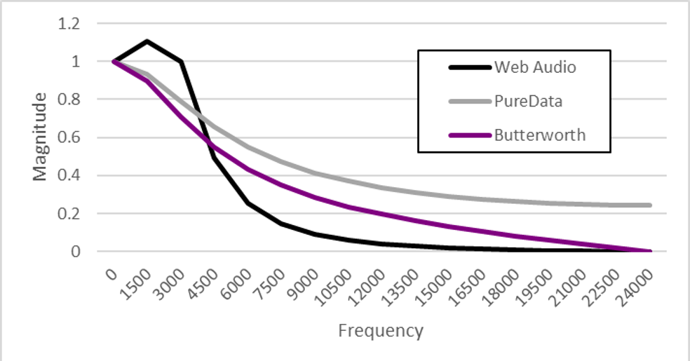
Figure 11.2. Magnitude responses for the Web Audio API's lowpass filter, PureData's lowpass filter, and the standard first order Butterworth lowpass filter.
Similar differences can also be seen if one investigates the highpass designs.

Figure 11.3 shows magnitude responses for the various bandpass filter implementations. The Web Audio API and the standard Butterworth implementations are very similar, but not exactly the same. The PureData implementation is very different. Like PureData's lowpass filter, its an fast approximation, and the magnitude does not go all the way to zero at the extremes. Its also not normalised for magnitude to go to 1 at the center frequency, and the specified center frequency is not the exact maximum. With suitable choice of this frequency and of Q, as well as adding a gain, you can get the magnitude response to be closer to the others, but it won’t be a very close match.
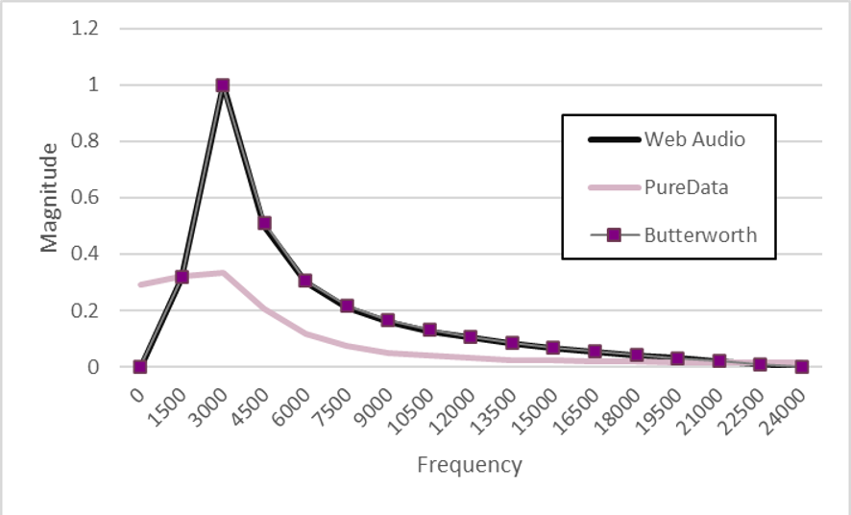
Figure 11.3. Magnitude responses for the Web Audio API's bandpass filter, PureData's bandpass filter, and the standard Butterworth bandpass filter design.
PureData does not implement peaking, notch or bandstop filters, and the Web Audio API's versions of those filters are also close to the Butterworth designs.
As mentioned, allpass filters leave the magnitude unchanged, but instead change just the phase. PureData does not come with an allpass filter, so in Figure 11.4 we just compare the Web Audio API's allpass filter with the standard Butterworth filter approach. The Web Audio API uses a second order (biquad) resonant filter, whereas the standard approach has a first order filter. First and second order allpass filters have very different properties. The first order filter’s corner frequency is where the phase response reaches -π/2, but the second order reaches π at the corner frequency. Also, the resonant filter causes a bump in the phase response at the corner frequency (that’s the resonance).
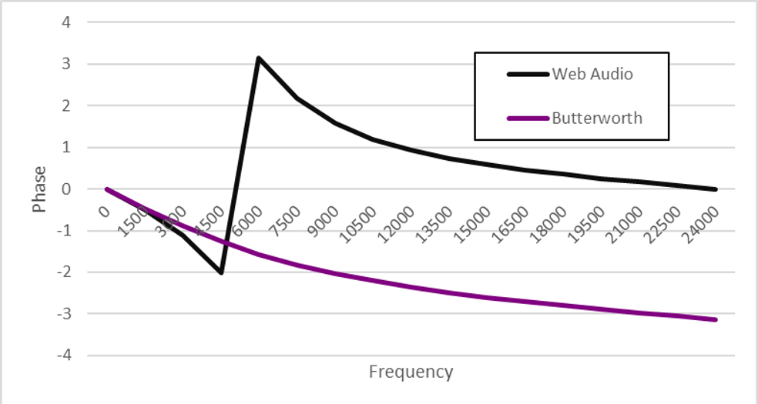
Figure 11.4. Phase responses for the Web Audio API's allpass filter and the standard Butterworth allpass filter design.

IIRFilterNode
There are many applications where a filter might be needed which cannot easily be built as a combination of the second order filters available in the BiquadFilter node. Thus, the Web Audio API provides the IIRFilterNode, which is an audio node that implements a general IIR filter. However, the IIRFilterNode has one huge drawback; the filter parameters cannot be automated, or even modified. That is, the coefficients of the IIR filter cannot be changed after the filter is initially created. For this reason, we later show how to create different filters using audio worklets.
Remember that IIR stands for infinite impulse response. So for a finite input, the output never fully decays to zero. But in practice, any stable filter’s output will eventually get arbitrarily close to zero and hence the filter can be treated as no longer processing.
The IIR filter is created either using
const iirFilter = context.createIIRFilter(feedForward, feedBack);
or
const iirFilter = new IIRFilterNode(context,{feedforward:[],feedback:[]});
The number of channels of the output always equals the number of channels of the input.

IIRFilterOptions
The options, feedforward and feedback must be set when the filter is created. They specify the coefficients of the filter.
- feedforward: An array of the feedforward (numerator) coefficients for the transfer function of the IIR filter. At least one element needs to be nonzero.
- feedback: An array of the feedback (denominator) coefficients for the transfer function of the IIR filter. The first element of the array cannot be 0.
The maximum length of these arrays is 20, meaning that the IIR filter node supports up to 19th order filters (a zeroth order filter still has one coefficient). The conditions that the first feedback element and at least one feedback element are nonzero guarantee that the output of the filter is specified and it is dependent on at least one input sample.

Methods
The IIR filter has only one method,
getFrequencyResponse(frequencyHz,magResponse,phaseResponse), which is exactly the same as the similarly named method for the IIRFilterNode.

Example- IIR filter visualiser
Code example 11.2 shows how to display the magnitude response of an IIR filter node. Here, we’ve separated the code into three files; one for html, one for the audio-related javascript, and one for the graphics-related javascript. Note that there are two contexts here, but with very different purposes. The AudioContext() handles Web Audio functionality whereas the getContext('2d') provides a drawing context for an HTML canvas.
Understanding the graphics code isn’t really necessary for understanding the Web Audio API aspects. The only relevant aspect is that it plots the magnitude values returned from the getFrequencyResponse method.
The filter that was applied is a fourth order Butterworth lowpass filter, designed to have a sharp cut-off at 1/100th of the sampling frequency (so 441 Hz for 44.1 kHz sample rate). Frequencies are plotted logarithmically, using the line
Freqs=Freqs.map(function(item,index) {return Math.pow(1.4,index)});
to fill the Freqs array with log-spaced frequencies.
<audio controls id='file' onplay='audioCtx.resume()'>
<source src='flange love.mp3'>
</audio>
<input type='checkbox' id='filterCheck'>Filtering<br>
<section class='filterGraph' id='graph' style='width: 60vw; height: 40vw;'>
<canvas id='canvas'>
</section>
<script src='audio.js'></script>
<script src='graphics.js'></script>

const audioCtx=new AudioContext()
let FF= [0.000113141981, 0.000339425943, 0.000339425943, 0.000113141981],
FB= [3.881838389832,-11.157788932074,10.700222288155,-3.423366610063]
const nFreqs=30
let Freqs=new Float32Array(nFreqs),
Mags=new Float32Array(nFreqs),
Phases=new Float32Array(nFreqs)
Freqs=Freqs.map(function(item,index) {return Math.pow(1.4,index)})
const iirfilter=audioCtx.createIIRFilter(FF,FB)
let source = audioCtx.createMediaElementSource(file)
source.connect(audioCtx.destination)
filterCheck.addEventListener('click', function() {
source.disconnect()
if (filterCheck.checked) source.connect(iirfilter).connect(audioCtx.destination)
else source.connect(audioCtx.destination)
})
iirfilter.getFrequencyResponse(Freqs, Mags, Phases)

// set 2d context and set dimensions
const canvasCtx=canvas.getContext('2d')
const width=graph.offsetWidth,height=graph.offsetHeight
canvas.width=width,canvas.height=height
canvasCtx.fillStyle='white'
canvasCtx.fillRect(0,0,width,height)
// draw & label axes
const spacing=width/16
const fontSize=Math.floor(spacing/1.5)
canvasCtx.beginPath()
canvasCtx.moveTo(spacing,spacing)
canvasCtx.lineTo(spacing,height-spacing)
canvasCtx.lineTo(width-spacing,height-spacing)
canvasCtx.stroke()
canvasCtx.font=fontSize+'px sans-serif'
canvasCtx.fillStyle='black'
canvasCtx.fillText('1',spacing-fontSize,spacing+fontSize)
canvasCtx.fillText('g',spacing-fontSize,(height-spacing+fontSize)/2)
canvasCtx.fillText('0',spacing-fontSize,height-spacing+fontSize)
canvasCtx.fillText('Hz',width/2,height-spacing+fontSize)
canvasCtx.fillText('Fs/2',width-spacing-10,height-spacing+fontSize)
canvasCtx.beginPath()// plot graph
canvasCtx.moveTo(spacing,height-Mags[0]*(height-2*spacing)-spacing)
for(let i=1; i < Mags.length; i++)
canvasCtx.lineTo(width*i/nFreqs,height-Mags[i]*(height-2*spacing)-spacing)
canvasCtx.stroke()
Code example 11.2. IIRFilterhtml, audio.js and graphics.js, for plotting the magnitude response of an IIR filter

Stability issues with Web Audio API filters
Stability is always a concern with filter design. For a stable filter, the output remains bounded if the input is bounded. Such filters generally do as intended. But if the filter is unstable, then the amplitude of the output may be higher than the amplitude of the input. As the output continues to grow, it can exceed any reasonable limits, causing the filter to ‘blow up’.
Code example 11.3 illustrates this phenomenon. We have a simple filter, y[n]= x[n] + c y[n-1], and the user can adjust c in discrete steps of 0.05. Each time c is changed, the existing IIR filter is disconnected and a new one, with the new coefficients, is connected in its place.
As long as c is less than 1, the filter remains stable. Any value of c greater than 1 will cause the output to grow exponentially. One can easily see this. For instance, if c=2, then an input stream with samples x[0]=1, x[1]=0, x[2]=0, x[3]=0, … will produce the output stream x[0]=1, x[1]=2, x[2]=4, x[3]=8… When c is equal to 1, the filter acts like a constant DC offset, the same as if a ConstantSourceNode was summed together with the source. However, setting c equal to 1 is still not recommended since the slightest imprecision could produce unstable behavior.
<input type='number' id='Coef' min=0 max=2 step='0.05' value=0>Coefficient
<audio controls id='file' onplay='context.resume()'>
<source src='flange love.mp3'>
</audio>
<script>
const context=new AudioContext()
let FF= [1,0], FB= [1,0]
let iirfilter=context.createIIRFilter(FF,FB)
let source = context.createMediaElementSource(file)
source.connect(iirfilter).connect(context.destination)
Coef.onchange = () =>{
FB[1] = -Coef.value
iirfilter=context.createIIRFilter(FF,FB)
source.disconnect()
source.connect(iirfilter).connect(context.destination)
}
</script>
Code example 11.3. IIRInstability.html, showing an IIR filter becoming unstable as a feedback coefficient changes.
In general, the filters used in the BiquadFilterNode are stable for any choice of parameter settings. So the output remains bounded if the input is bounded. However, if the filter parameters are changed very rapidly, like from extreme parameter automation, then one can create an unstable biquad filter. The output will then ‘blow up’. This is shown in Code example 11.4.
<button onclick='context.resume()'>Start</button>
<input type='range' id='modFreq' min=0 max=1000 step='any' value=100>
<script>
var context = new AudioContext()
var osc1 = new OscillatorNode(context,{frequency:80})
osc1.start()
var filter = new BiquadFilterNode(context,{frequency:200})
var osc2 = new OscillatorNode(context,{frequency:100})
osc2.start()
var modGain = new GainNode(context,{gain:3600})
osc1.connect(filter)
osc2.connect(modGain).connect(filter.detune)
filter.connect(context.destination)
modFreq.onchange = function() { osc2.frequency.value = this.value }
</script>

Code example 11.4. BiquadInstability.html, showing a biquad filter becoming unstable as a feedback coefficient changes.
Here, we have two oscillators. The first one connects to a BiquadFilterNode which then connects to the destination. The second oscillator modulates the frequency of the biquad filter, by changing the detune parameter. Since the oscillator varies between -1 and +1, and is multiplied by a gain of 3600, the biquad filter’s computed frequency now ranges from 2^{-3600/1200·}200=0.25 to 2^{-600/1200·}200=1600. At the default frequency for the second oscillator, 100, it does this every 10 milliseconds. But when this frequency is increased, it changes the biquad filter’s cutoff frequency at a faster rate, which causes instability.
For most uses, this instability won’t occur. But if it does, it can be particularly problematic since the filter may produce NaN (not a number) values. These then propagate for all future values, resulting in the filter producing silence even if the parameters are reset to values that ordinarily. If this happens, you may need to consider restricting the range of allowable values for parameter automation.

see https://webaudio.github.io/Audio-EQ-Cookbook/audio-eq-cookbook.html
based on code and discussion at https://bugs.chromium.org/p/chromium/issues/detail?id=717727

